#
# 20170915
#
# Original distributive located here.
[s.belogrud.TCS4357] b ls /drives/e/data/distributives/comwault/
comwault_simpana_agent_linux_x86_64.tar

# Here is how extract it and run installation procedure.
[root@m1-mvno-db01-prod ~]# mkdir /tmp/comwault
[root@m1-mvno-db01-prod ~]# tar -xf /tmp/comwault_simpana_agent_linux_x86_64.tar -C /tmp/comwault/
[root@m1-mvno-db01-prod ~]# cd /tmp/comwault/DownloadPackageLocation/
[root@ds-mvno-db01-prod DownloadPackageLocation]# ./cvpkgadd

# It needs to choose appropriate
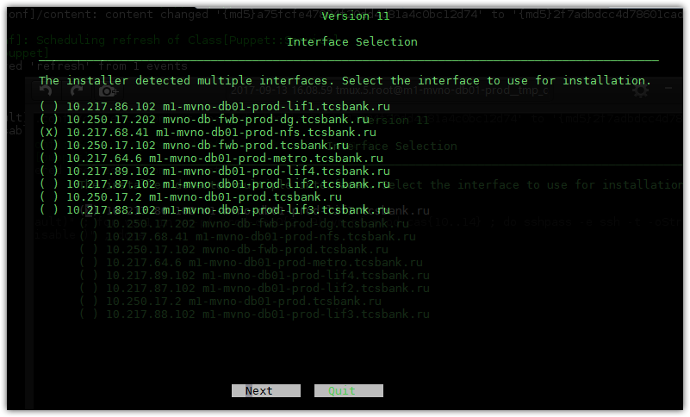

# This checkboxes were selected if on server installed postgresql software.
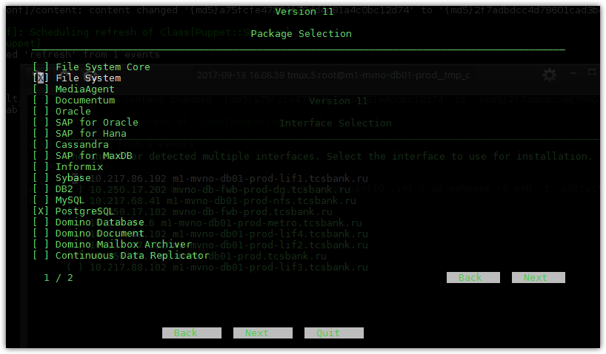

# This is for Oracle software.
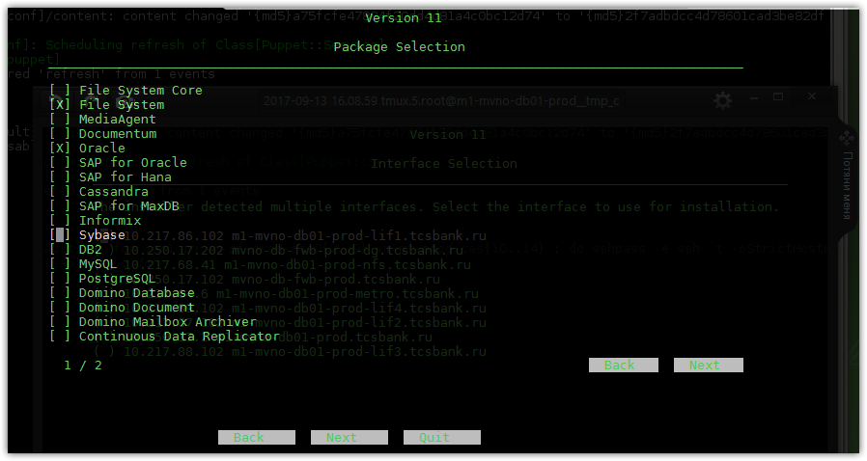

# I’m not sure about it. One time we try to use this option.
